|  |
| --- |
| Assessement  **%** |

**Name**: Samuel Černý **Class: 2.A**

**Topic: Czech Republic**

**Three interesting introductory sentences to the topic:**

1. Prague castle is the largest ancient castle in the world!

2. The word „robot“ was invented in Czech Republic.

3. Czech Republic is one of the least religious countries in the world.

**Words associated and connected to the topic given:**

|  |  |  |  |  |
| --- | --- | --- | --- | --- |
| Prague | beer | Velvet revolution | Rožmberg | Ice hockey |
| Macocha abyss | contact lenses | Svíčková | democracy | atheism |
| Petr Pavel | Šumava | Vltava | Sněžka | tennis |
| Charles IV | Baťa | robot | Sámo | senate |

**Create a sentence:**

**- in Present simple tense:**

Residents of Czech Republic love Svíčková.

**- in Present perfect:**

We have been split apart with Slovakia since the year 1993.

-**in Past Simple:**

Before Petr Pavel became a president, Miloš Zeman was a president.

**Conditional clause:**

I wish I could talk to Charles IV, I want to ask him so many thing!

**Make up 3 interesting complex sentences (souvětí):**

1. First there was the Empire of Merchant Sámo, after that we’ve been in the Great Moravian Empire, later on we’ve been in the era of Charles IV, with a blink of an eye Czechoslovakia was our land, and now we’re Czech Republic.

2. Czech Republic brought alot to the world, one of the most important thing are of course contact lenses, but as we go down the list, we see the word „robot“, or even blood groups that were first defined by Jan Jánský.

3. We also have some amazing sport legends, the greatest javelin thrower comes from Czech Republic, who else would I mention than Jaromir Jagr of course, everyone knows his name, and the biggest legend of them all, the Greatest Athlete of the Twentieth Century, Emil Zátopek.

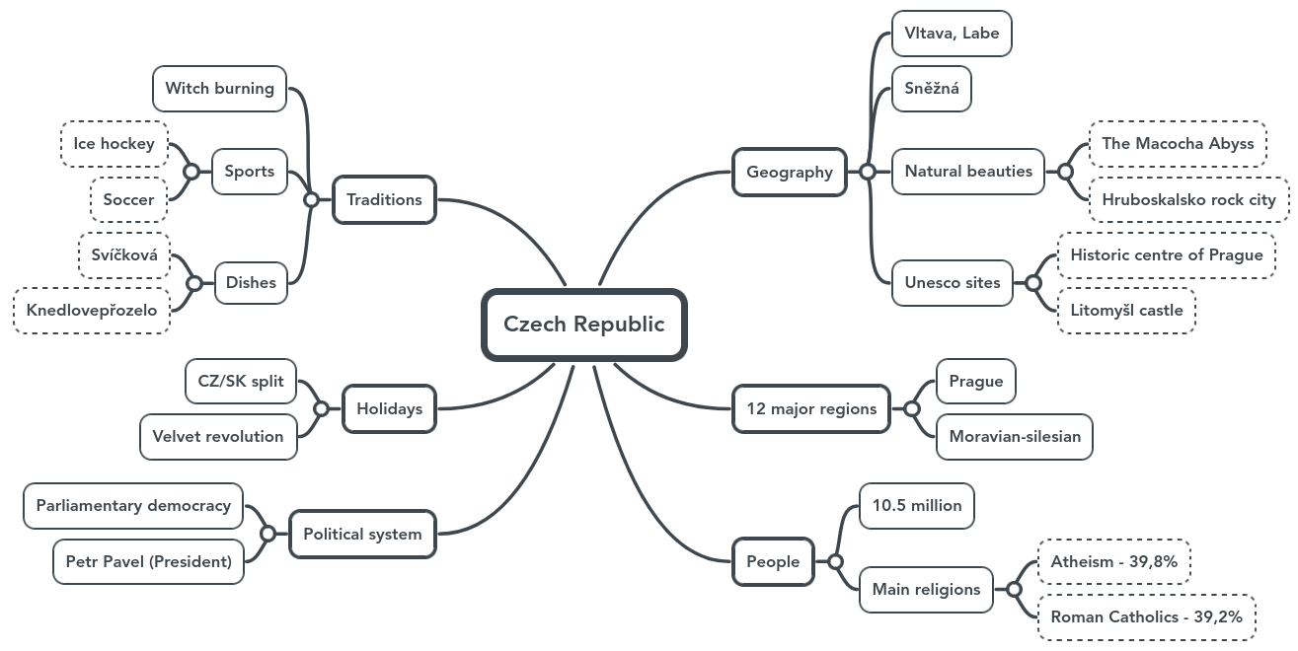**Mind map – Outline more or less detailed mind map (according to your learning abilities and preferences, or use bulleted point to work out a summary of the topic):**